Cook book

Your virtual Kitchen Assistant

**Team id**:

NM2025TMID40233

**TEAM DETA*ILS:***

**TEAM ID**: NM2025TMID40233

**PROJECT TITLE:** Cook book : your virtual kitchen assitant

**TEAM LEADER:** DEEPIKA.N

**NM ID**: DE90F09455FA89DB9944E2043D8900E

**MAIL ID:**

**TEAM MEMBER:** SIVA.M

**NM ID** : F6713FA6F17E138B4964974C1ABF45AF

**MAIL ID:**

**TEAM MEMBER:** VEERASEKAR.S

**MAIL ID:**

**NM ID** :  D8F3ECF83D328028A344430EB39D2ED7

**TEAM MEMBER:** SHYAM KUMAR .A

**NM ID** :  1E917C45EA9DBF289DF4BF34D8B96436

**MAIL ID:**

**ARCHITECTURE:**

**FRONTEND**: React.js with bootstrap and material UI

**BACKEND**:NODE.js and

**OBJECTIVE:**

The aim of this project is to build a virtual kitchen assistant that helps users explore, save, and prepare recipes easily.

Key Points:

Provide a collection of recipes with clear instructions.

Allow users to search recipes by ingredients, cuisine, or meal type.

Suggest dishes based on available ingredients.

Save favorite recipes for quick access later.

Make cooking easier with step-by-step guidance

Platform & Technology Used:

The project is developed as a web-based application to ensure accessibility and ease of use across devices with a modern browser. The following technologies and platforms are used:

React: A powerful JavaScript library for building interactive and component-based user interfaces.

HTML5: Used for or structuring the web pages and defining the content of the application.

CSS3: Utilized for styling and designing a responsive, user-friendly, and visually appealing interface.

JavaScript (ES6+): The core programming language used for implementing business logic, interactivity, and communication between components.

Git: A version control system used for managing code, tracking changes, and maintaining project versions effectively

**IMPLEMENTATION/PROCESS:**

**1. Home Page**

Displays featured and trending recipes.

Acts as the main entry point for users.

**2. Recipe Search**

Users can search recipes by name, ingredient, or cuisine.

Provides quick filtering for vegetarian, vegan, or non-veg dishes.

**3. Recipe Details**

Each recipe includes ingredients, preparation steps, cooking time, and serving size.

Designed in a simple, readable format.

**4. Ingredient-Based Suggestions**

Users can enter available ingredients.

The system suggests suitable recipes they can prepare.

**5. Favorites & Personalization**

Option to bookmark or save favorite recipes.

Personalized suggestions based on saved recipes.

**6. User-Friendly Interface**

Clean and responsive design for use on mobile or desktop.

Easy navigation between categories and features.

**7. Testing & Deployment**

The website is tested for errors and usability.

Deployed online for user access

**OUTPUT/RESULT:**

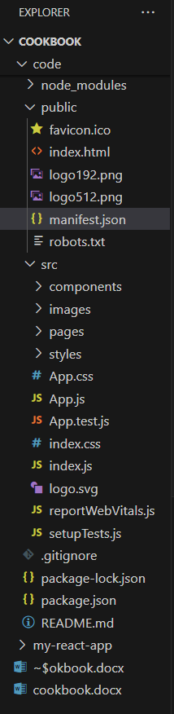

**PROJECT STRUCTURE**

**HOME PAGE:**

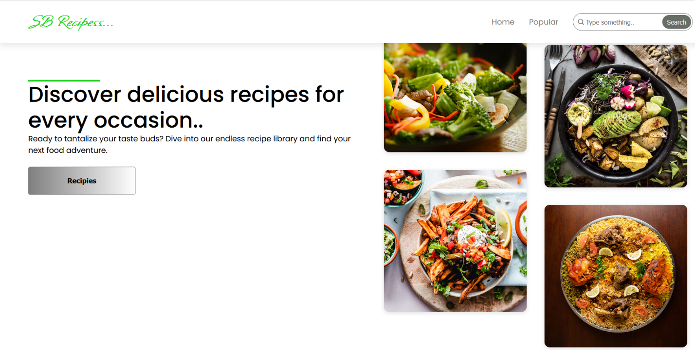

**MOST POPULAR CATEGORIES:**

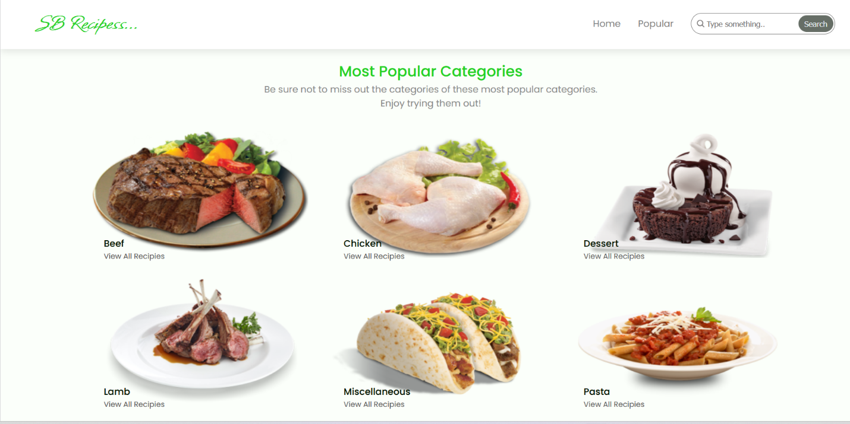

**RECIPESS:**

**Strawberries Romanoff**

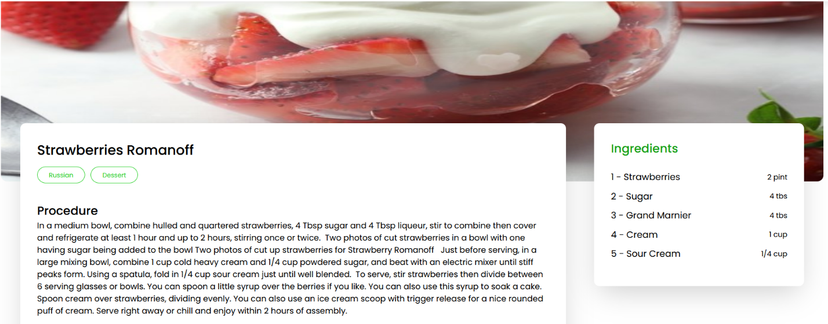



**VIDEO TUTORIAL:**

